Szállások listája - List of hotels

- Hotel Kamilla „4 Star”
- 52 rooms with 2 beds, 104 persons
- 62 Euro / person / night
- 1 Euro Tourist tax, over 18 years / person / night
- A 30% surcharge applies for accommodation for 1 person
- Breakfast and buffet dinner are included in the price.
- Web.: hotelkamilla.com
- Address : 4060. Balmazújváros, Kastélykert street 1-2.
- 25 km. from the Sports Hall
- 24-hour use of the hotel's spa pool
- Free WiFi, Free parking
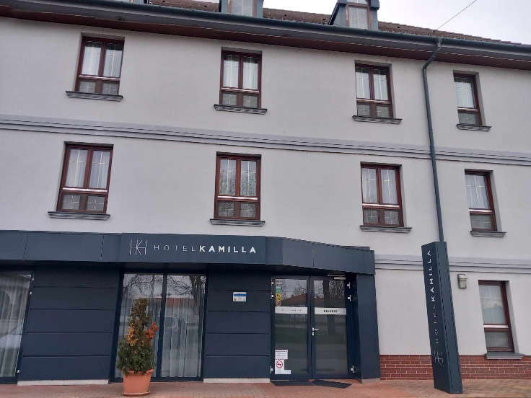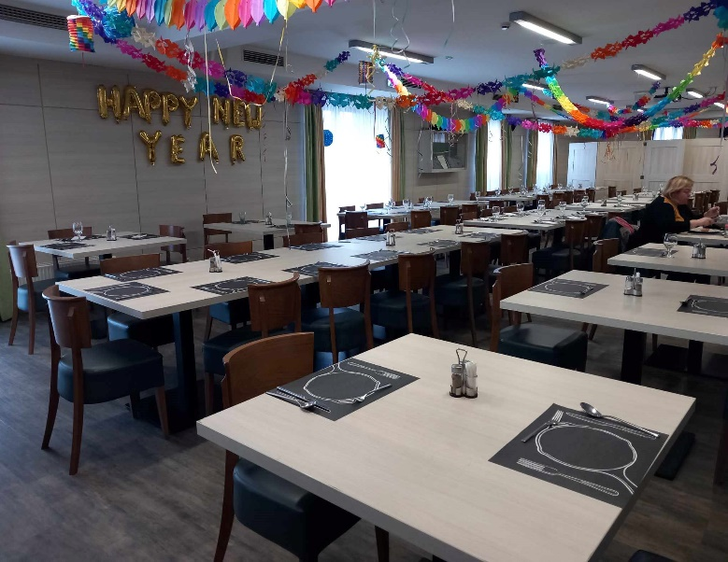

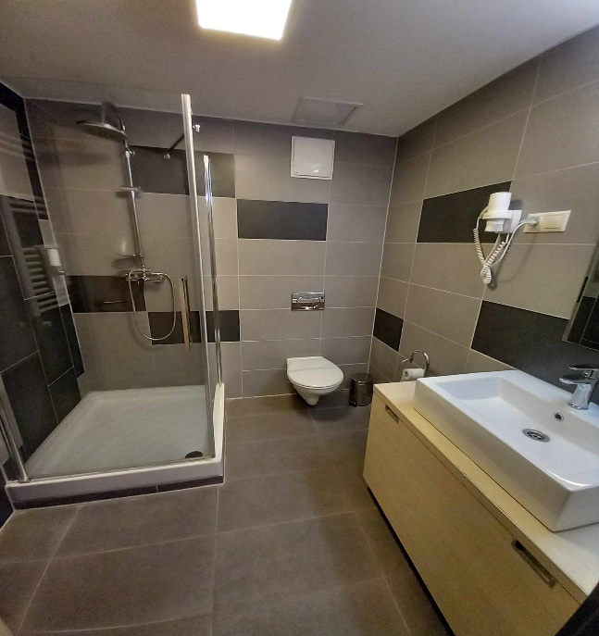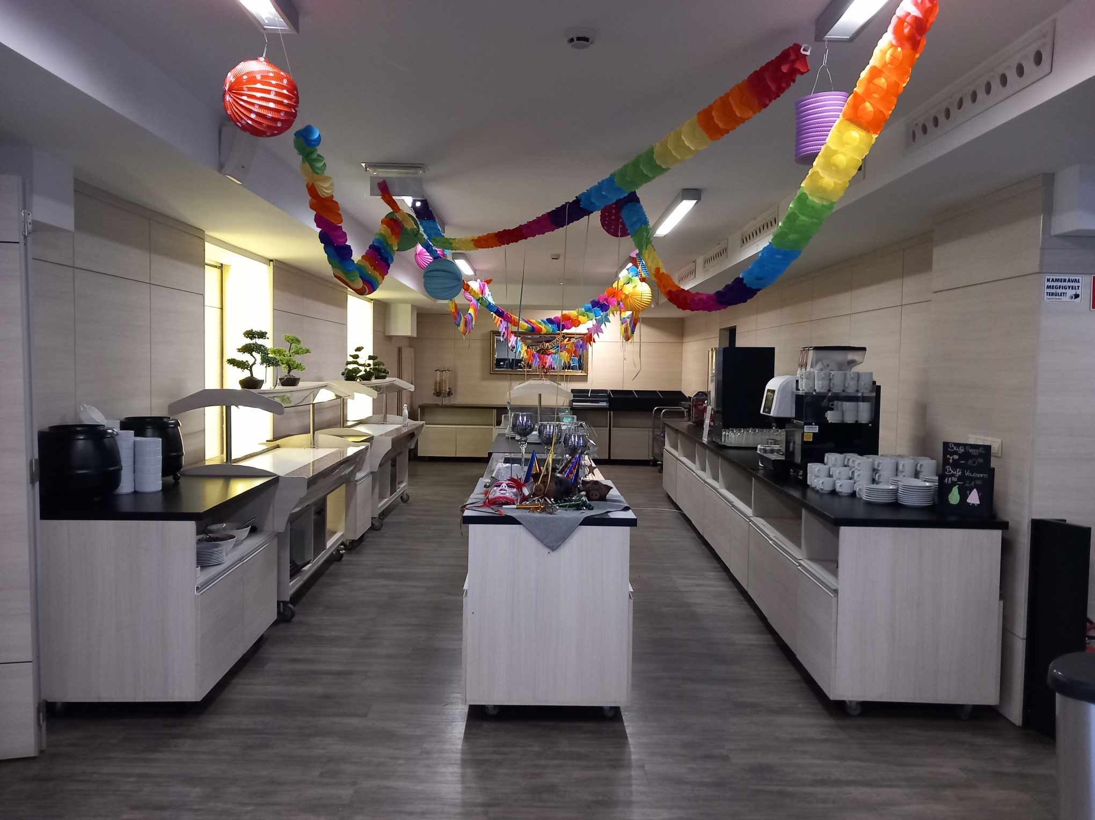

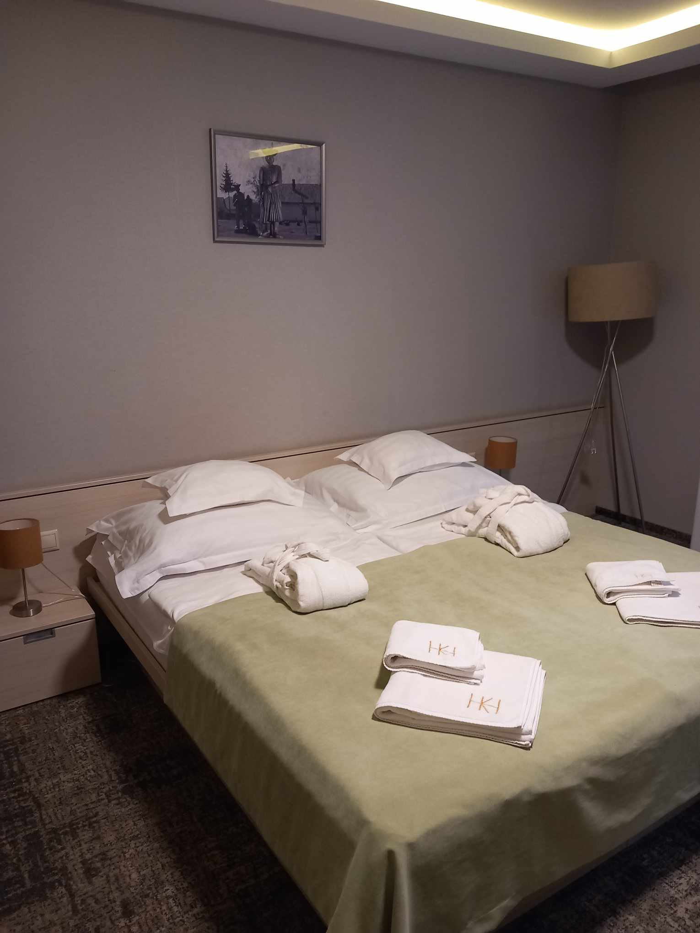

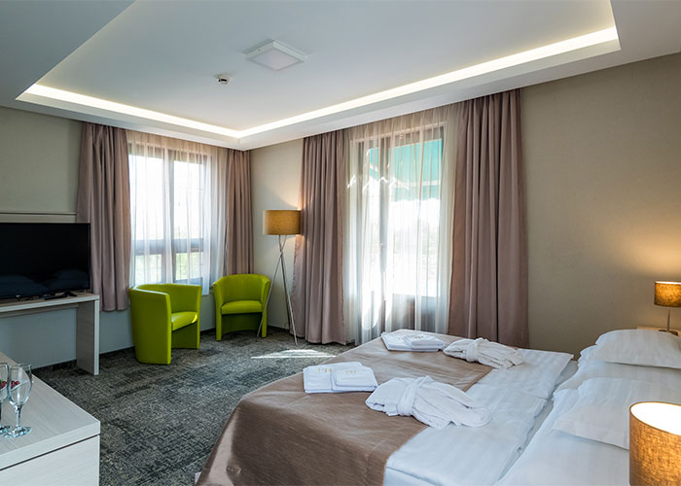

- Debreceni Sport Hotel „3 Star”
- Single and double rooms
- 70 persons
- Single room 65 Euro / person / night
- Double room 49 Euro / person / night
- 1 Euro Tourist tax, over 18 years / person / night
- Buffet breakfast, Dinner with plate service
- Web.: www.debrecenisporthotel.hu
- Address : 4032. Debrecen, Oláh Gábor street 5.
- 1000.m. from the Sports Hall
- Free WiFi, Free parking

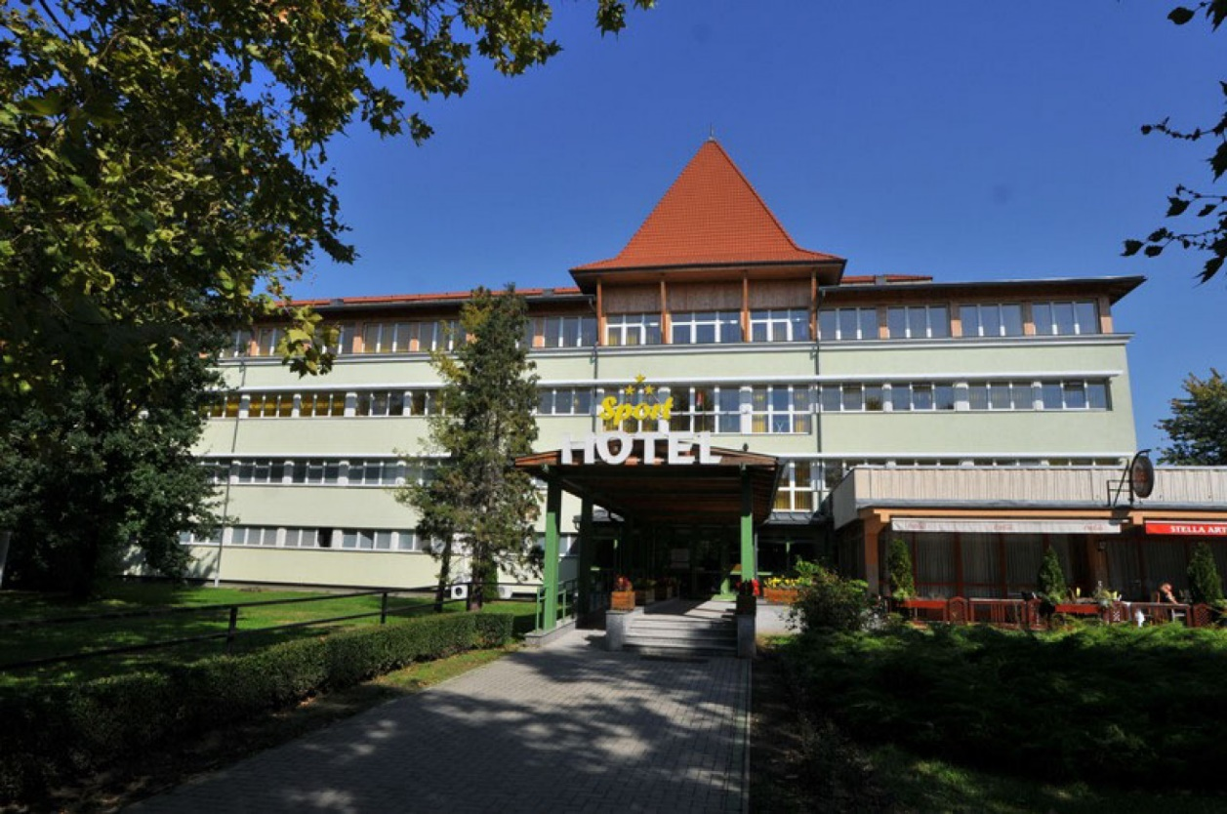

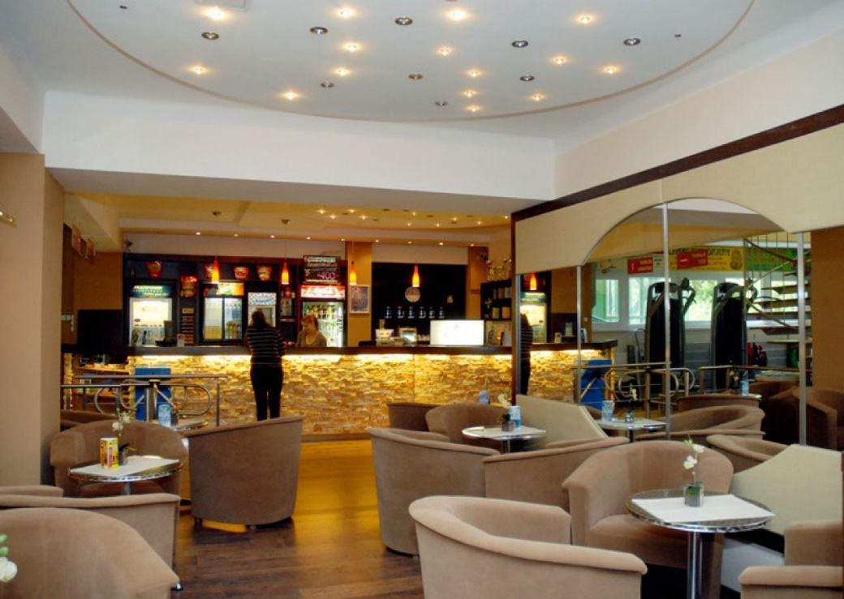

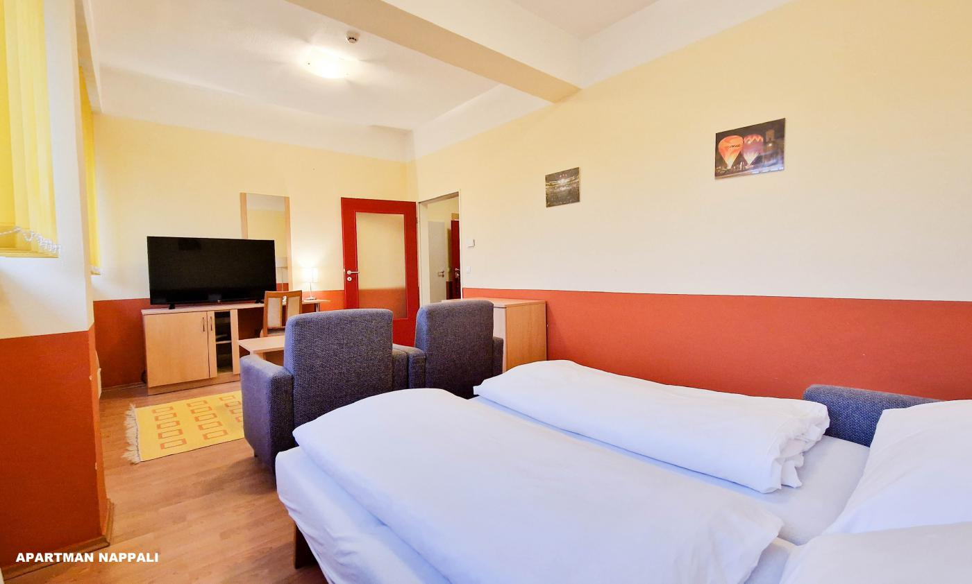

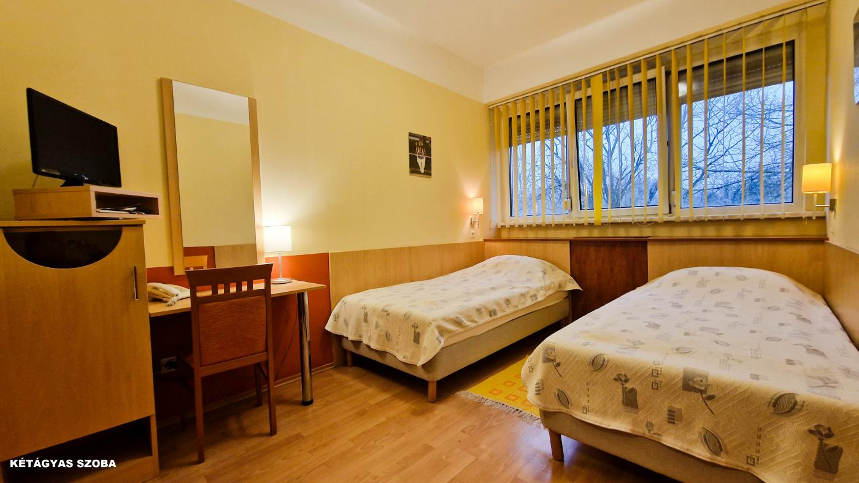

- Forrás Hotel-Panzió
- 55 persons, plus 13 persons extra beds available
- total 68 persons
- 3 single room
- 21 double room
- 2 triple room
- 1 four beds room
- 47,5 Euro / person / night
- 1 Euro Tourist tax, over 18 years / person / night
- Breakfast and buffet dinner are included in the price.
- Web.: www.forras-panzio.hu
- Address : 4200. Hajdúszoboszló, Szabó László zug 14.
- 25 km. from the Sports Hall
- Free Parking

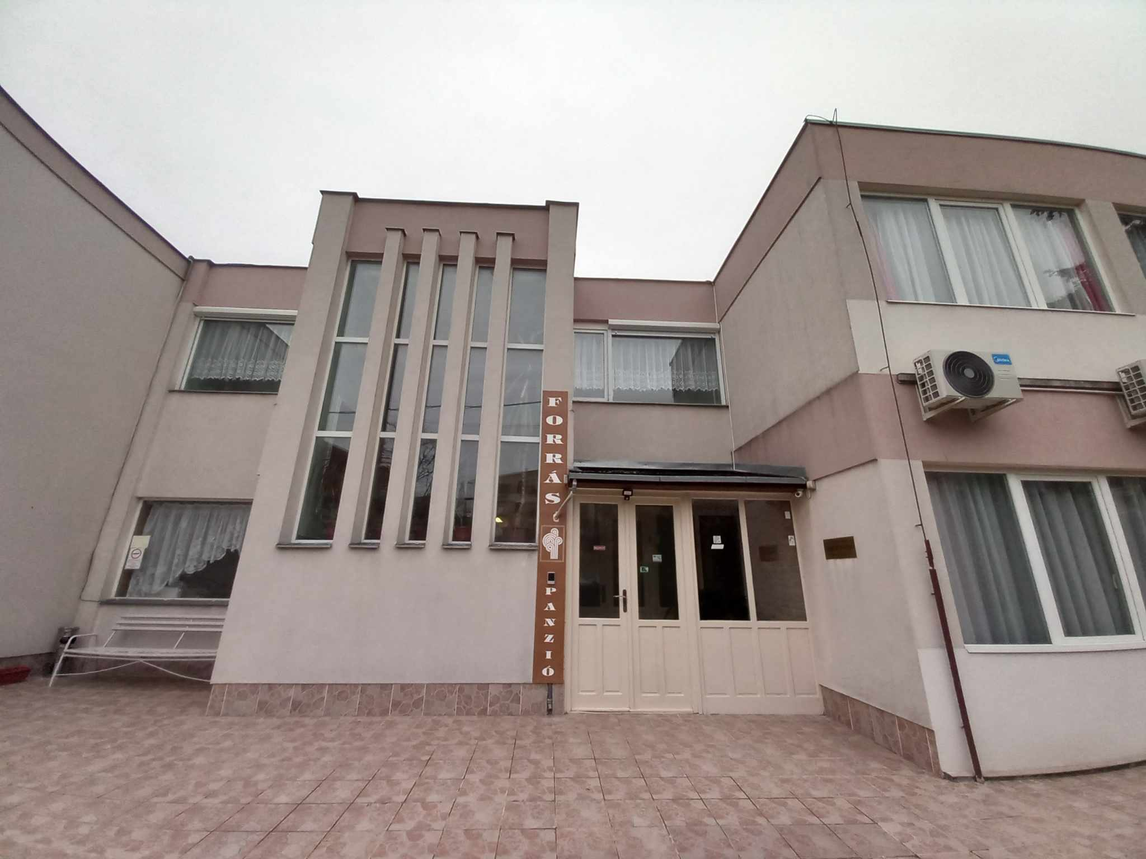

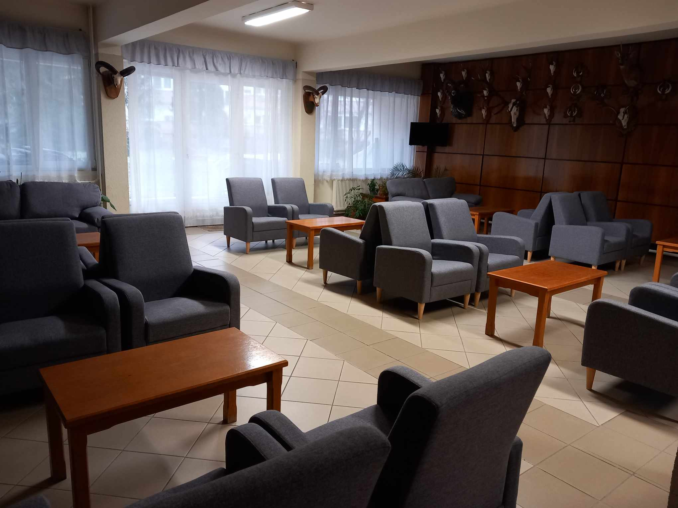

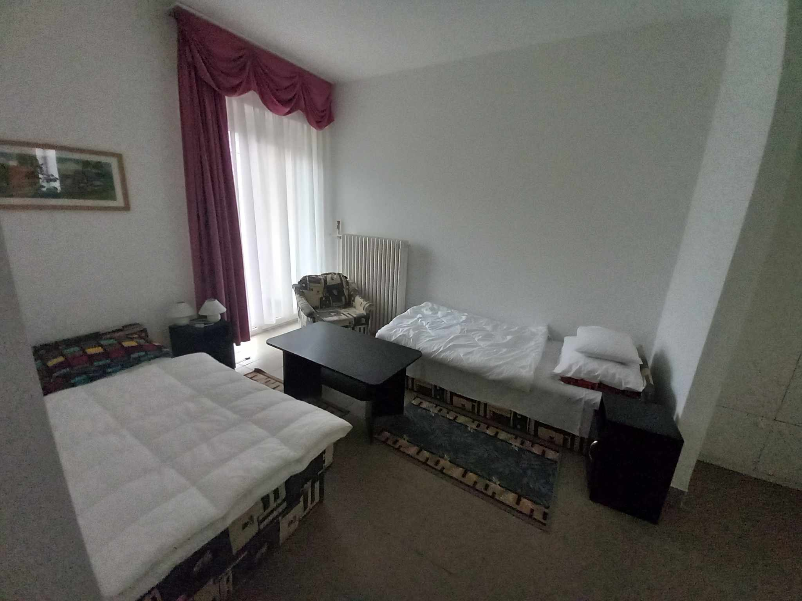

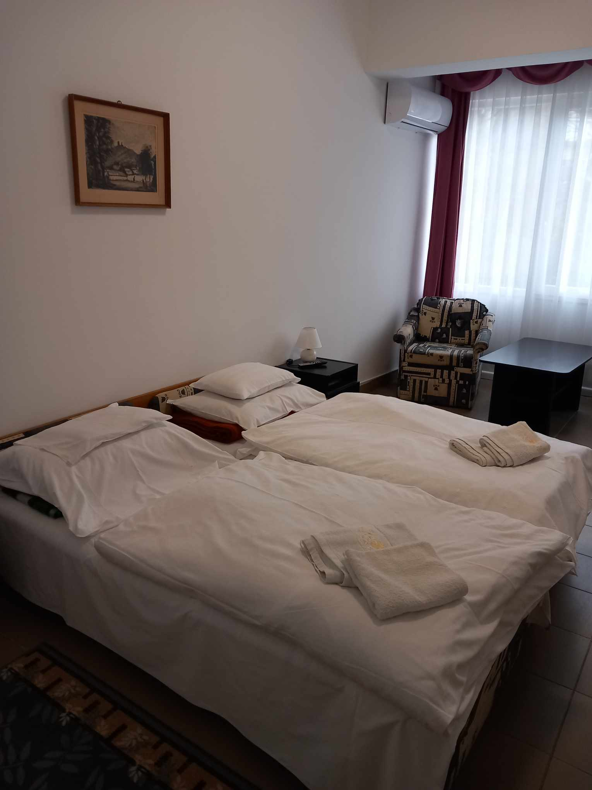

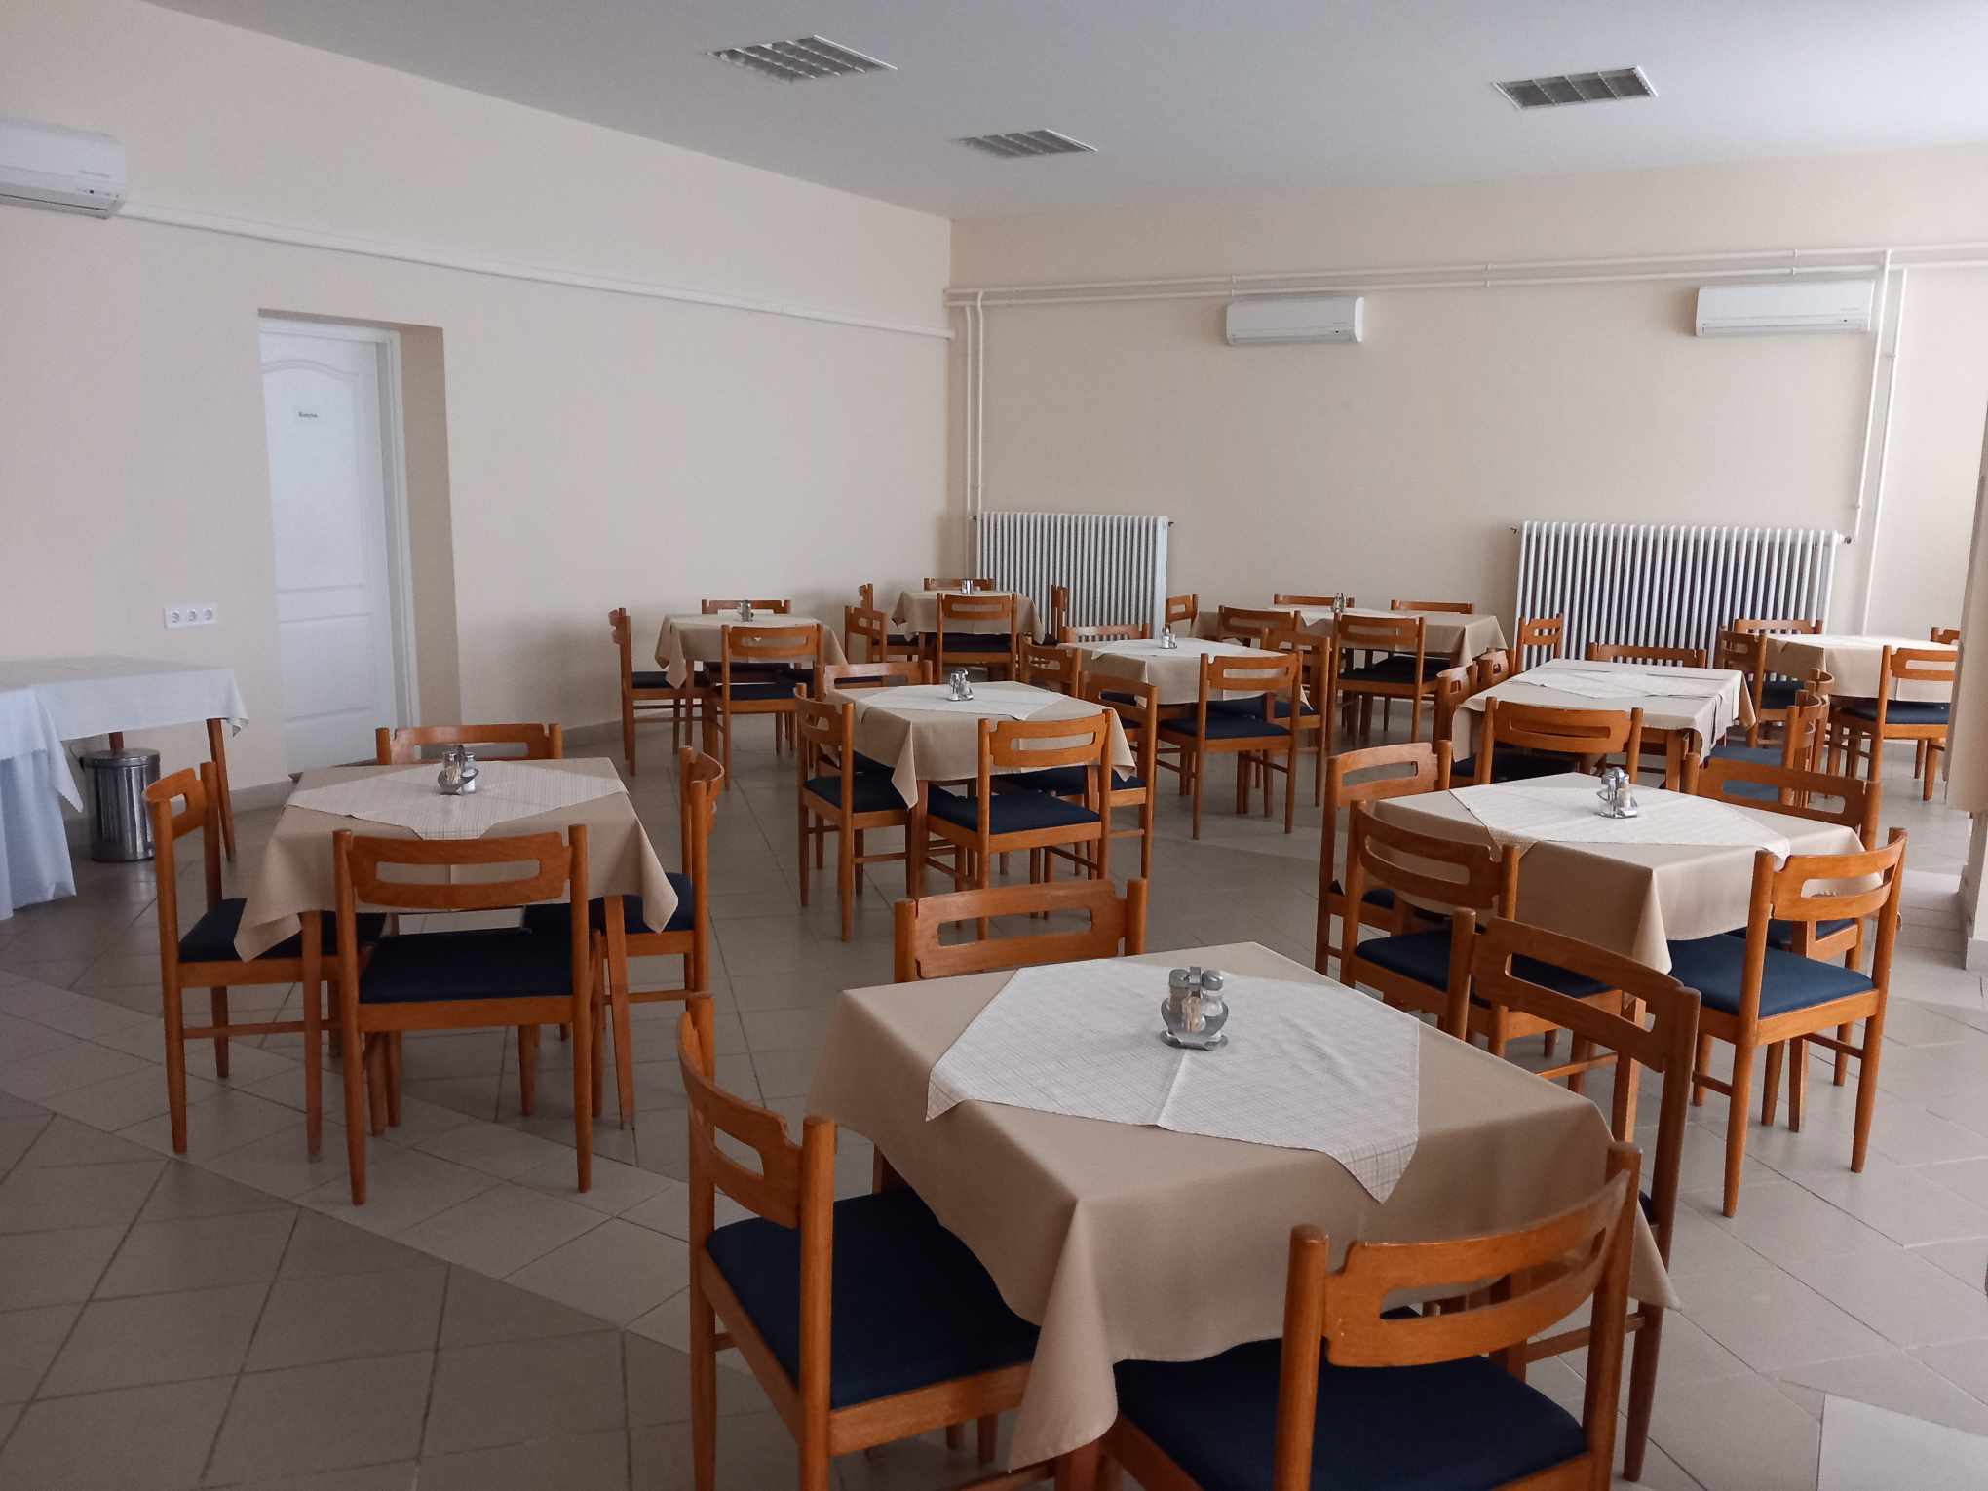

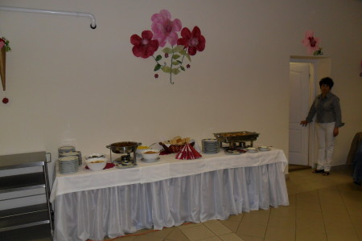

- Borostyán Med Wellness Hotel „4 Star”
- Standard double bed 88 Euro / person / night
- Superior double bed 92 Euro / person / night
- total 240 persons
- 1 Euro Tourist tax, over 18 years / person / night
- Breakfast and buffet dinner are included in the price.
- Web.: www.borostyanmedhotel.hu
- Address : 4252. Nyíradony-Tamásipuszta, Akácos street 21.
- 23 km. from the Sports Hall
- 24-hour use of the hotel's spa pool
- Free WiFi, Free parking

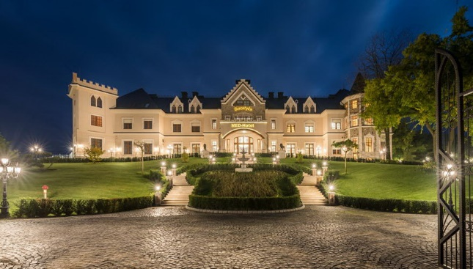

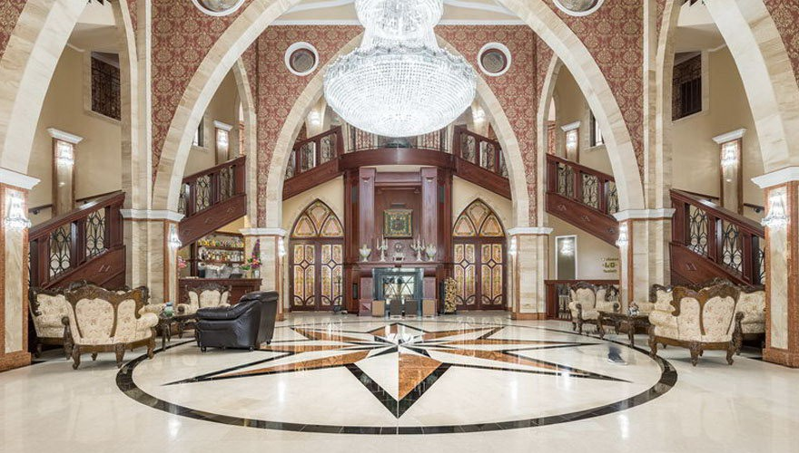

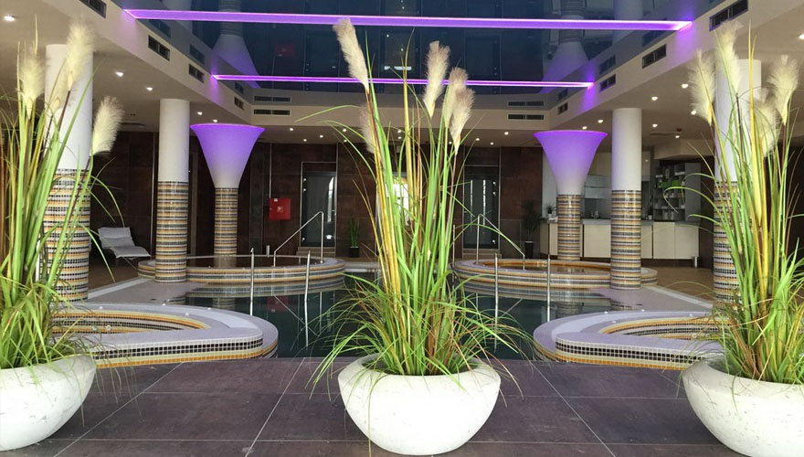

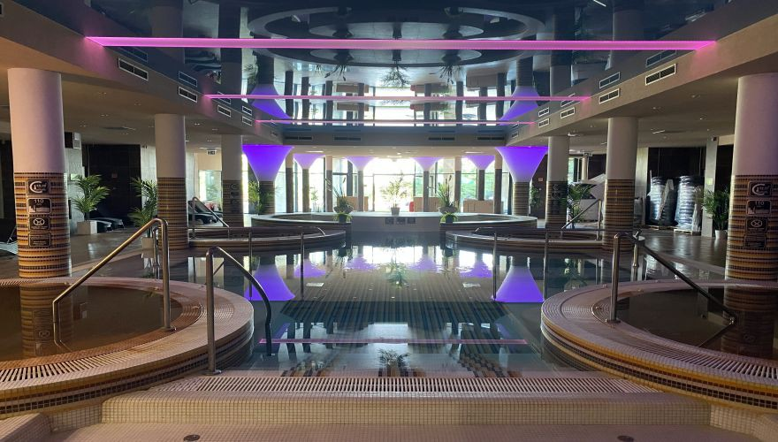

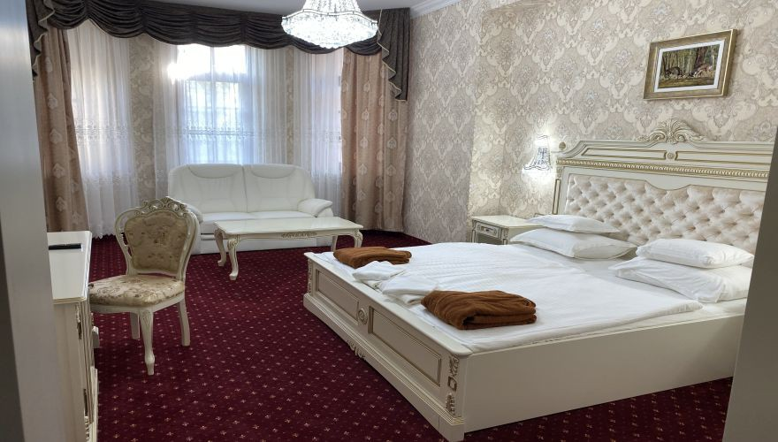

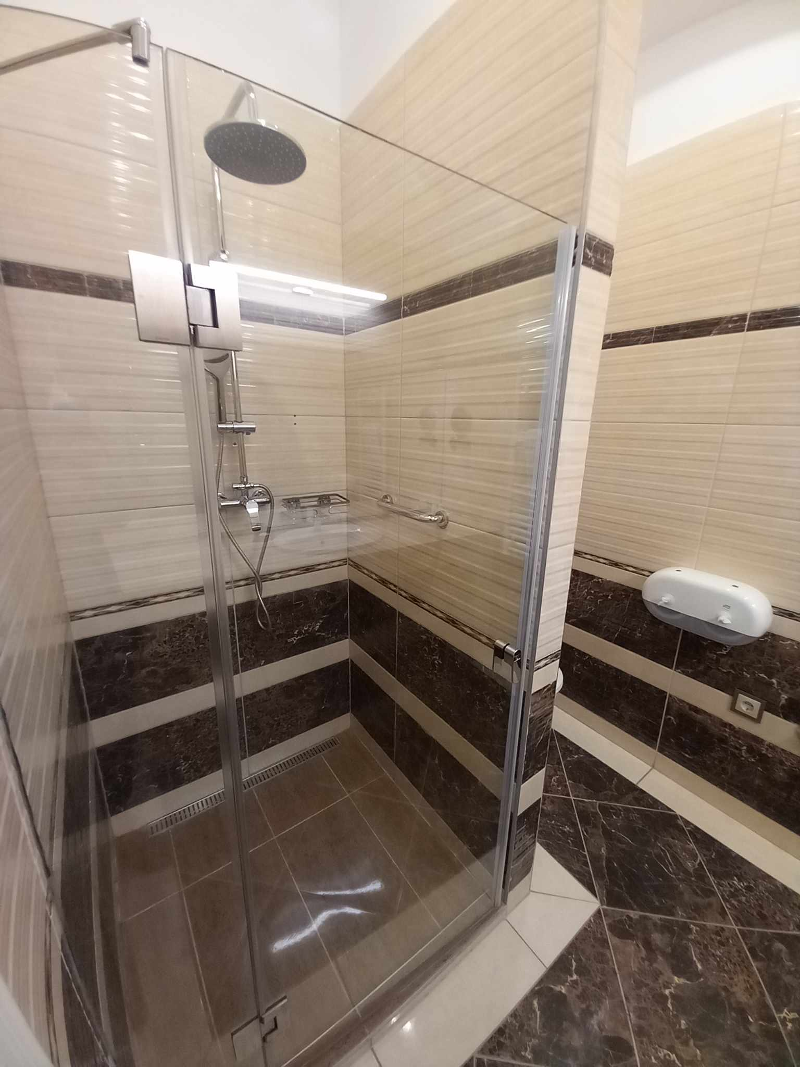

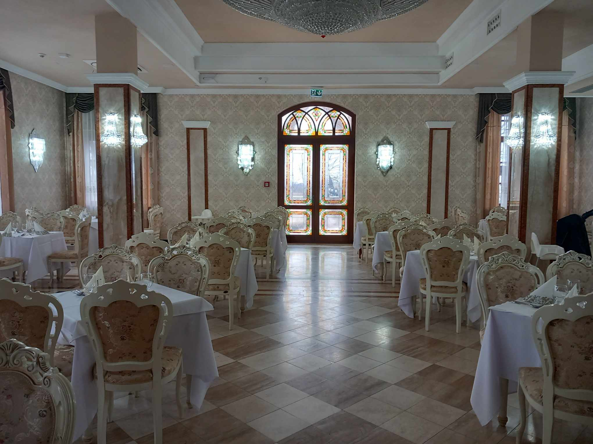

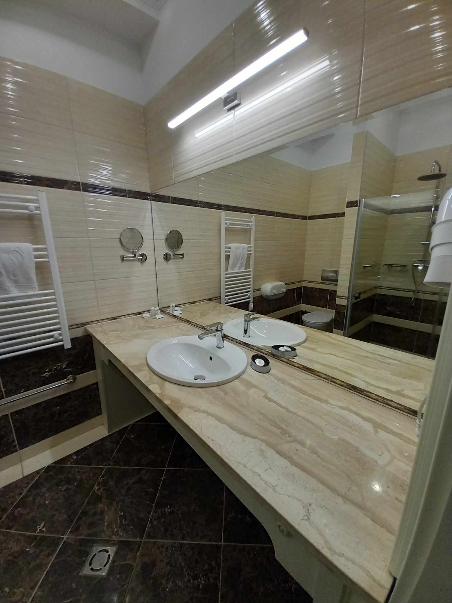

- Hotel Délibáb „4 Star”
- 33 classic double bed room
- 34 classic balcony double bed room
- 134 persons
- 68 Euro / person / night
- 1 Euro Tourist tax, over 18 years / person / night
- Buffet breakfast and buffet dinner.
- Web.: www.hoteldelibab.hu
- Address : 4200. Hajdúszoboszló, József Attila street 5-7.
- 25 km. from the Sports Hall
- unlimited wellness service during opening hours
- Free WiFi,
- Parking 4 euro /day

